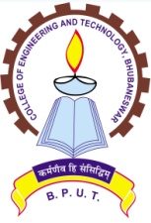
COLLEGE OF ENGINEERING AND TECHNOLOGY

(A Constituent College of Biju Patnaik University of Technology)

TECHNO CAMPUS, GHATIKIA, PO: MAHALAXMIVIHAR, BHUBANESWAR-751 029

Letter No. 2776 / CET Dated 04.10.2019

NOTICE

The SC/ST students of this college, who have completed their degrees during the year 2001 to 2012 and have not received their Post Matric Scholarship (PMS) in spite of repeated notices are advised to receive the said scholarship from college during any working day on or before 15-11-2019 with production of identity proof (Aadhar Card / PAN Card / Voter ID etc.) and bank details. The said students are advised to come personally to academic section for credit of their scholarship into their respective bank account. For further details please log into the college website www.cet.edu.in

Sd/-

PRINCIPAL

